MSC BIG DATA ANALYTICS

DATABASE MANAGEMENT SYSTEM

LAB RECORD – 1

SIYONA SEBASTIAN 232BDA16

***1)Create database labrecord.***

*Create database labrecord;*

***2)Use labrecord.***



***3)Create table student.***

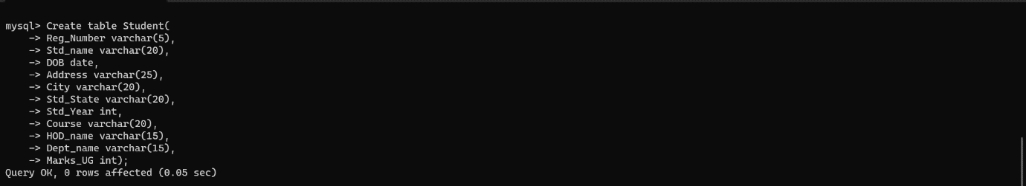

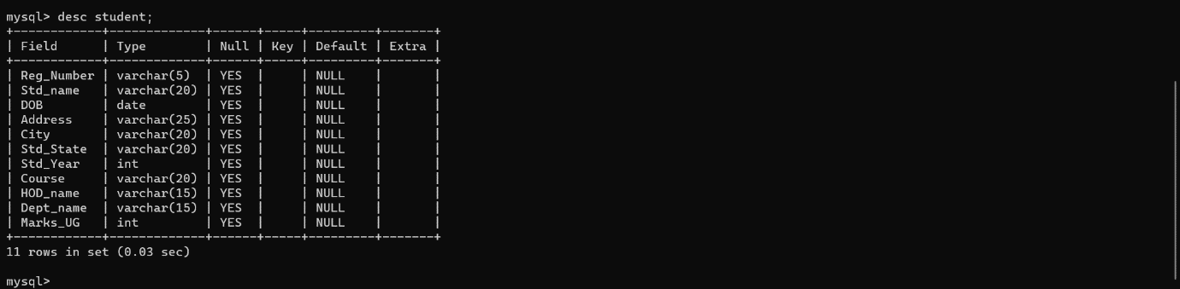

***4)Show different tables under labrecord.***



***5)Show the structure of student.***



***6)Insert 5 records to student table.***

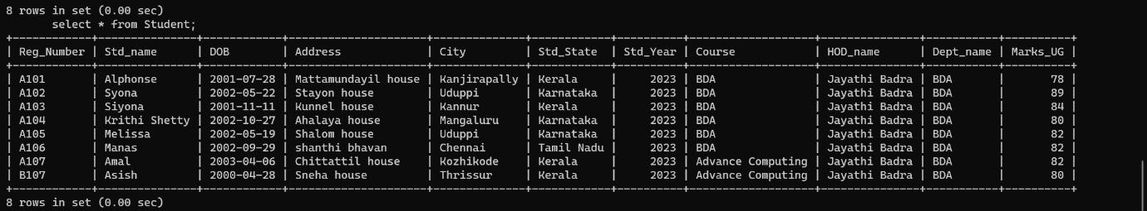

***7)Display all the records.***



***8)Select student details who belong to state Tamil Nadu.***



***9)Display the student’s details who belong to first year and the course is advanced computing.***

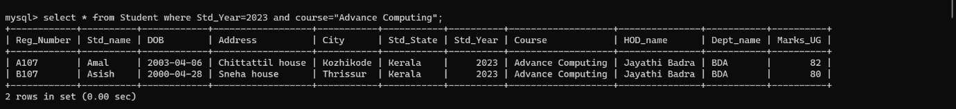

***10)Display the names of students born after 1 jan 2000.***

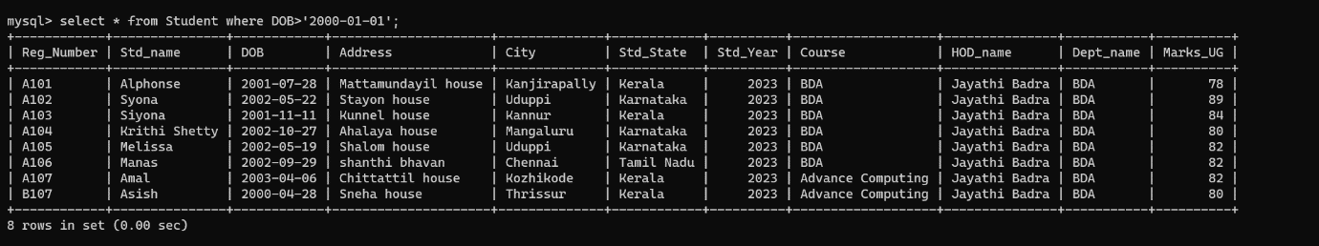

***11)Order the data according to ascending order of name.***

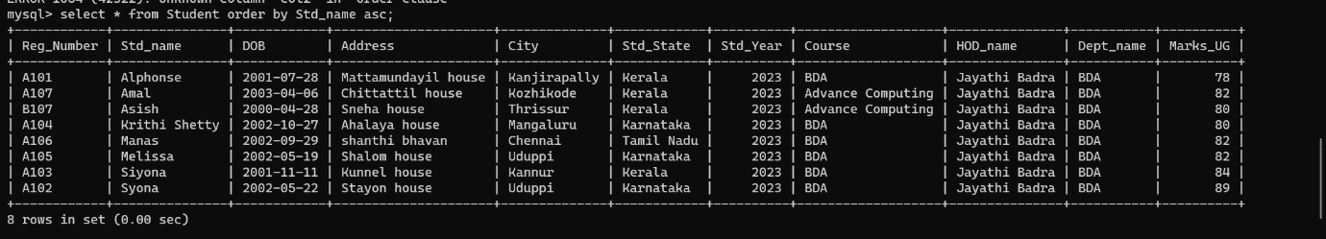

***12)Order the data according to register name descending.***

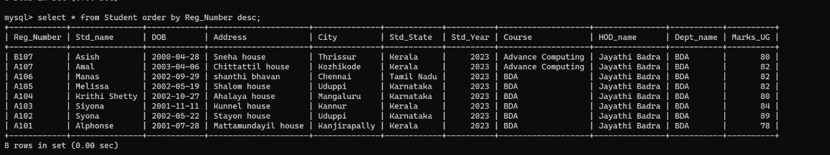

***13)*** ***Display the names and register number students.***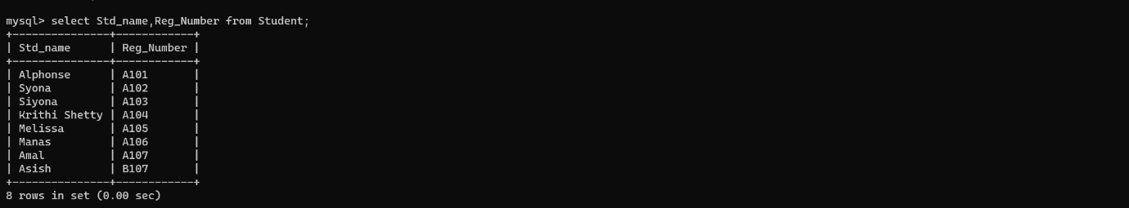

***14)Display the unique courses.***

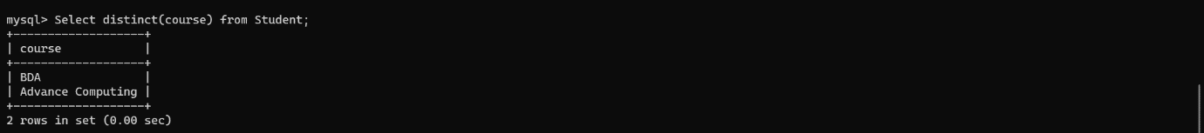

***15)Is it possible to order any columns.***

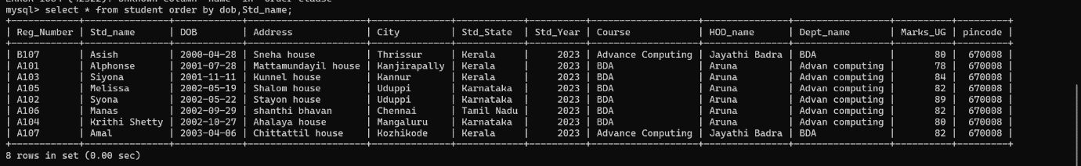

***16)Show total number of rows.***

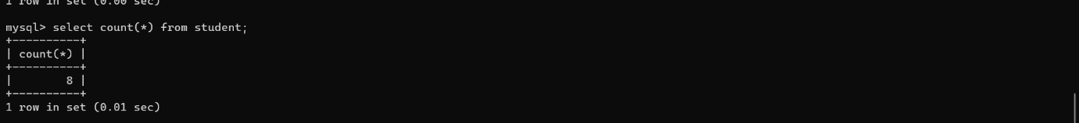

***17)Show the name of student who scored marks max in pu.***



***18) Show the name of student who scored marks min in pu.***

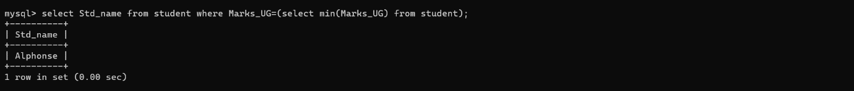

***19)How to work with average function.***

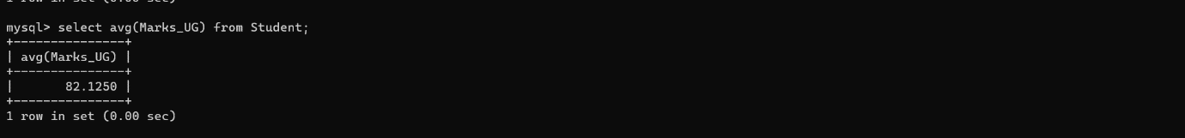

***20)How to rename the column using select statement.***

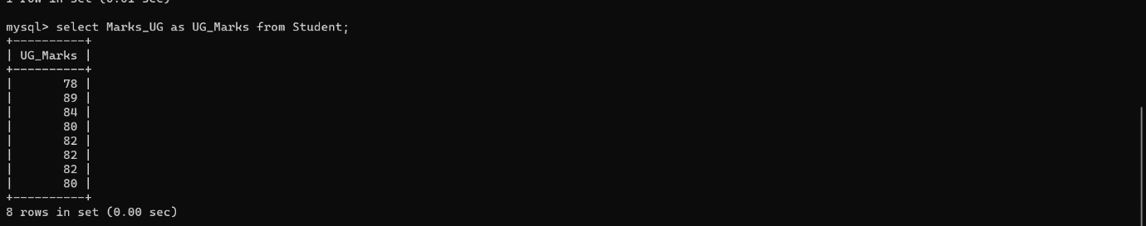

***21)Add a new column pin code and insert value to it?***

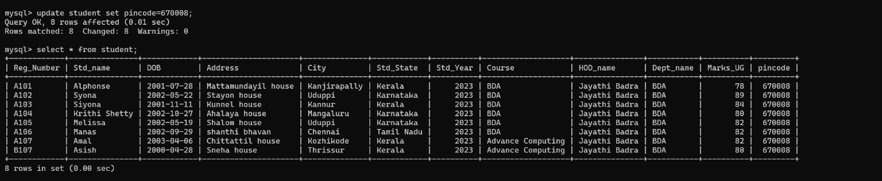

***22)Delete a column.***

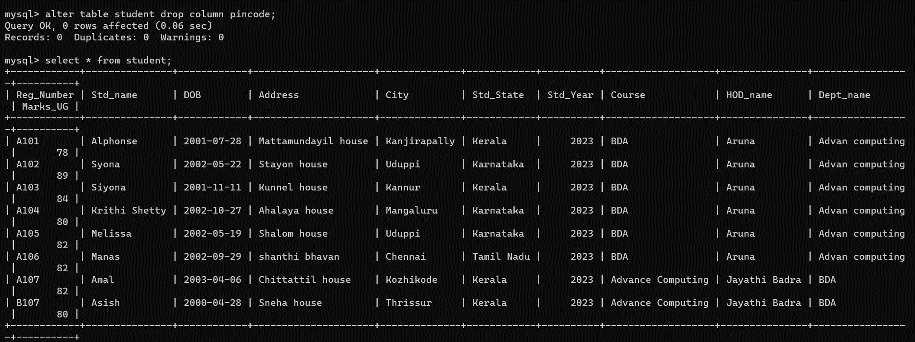

***23)Give an example for range searching.***



***24)Give an example for and.***



***25)Give an example for or.***



***26)Give an example of not.***

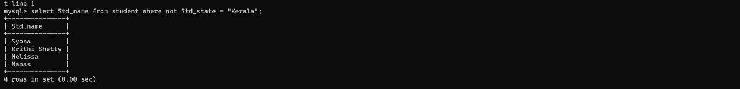

***27)Display Student name start with letter ‘a’?***

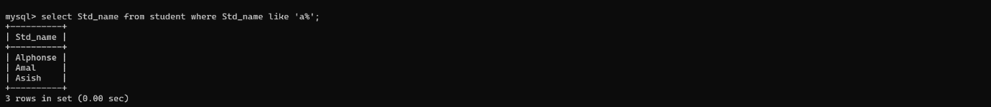

***28)Display student name ends with letter ‘a’?***



***29)display students name that starts with a and ends with e?***



***30)Display student name that start with a and ends with l with length 4?***



***31)Display names of student whose second letter is e?***



***32)Display names of student whose name contains ‘on’?***

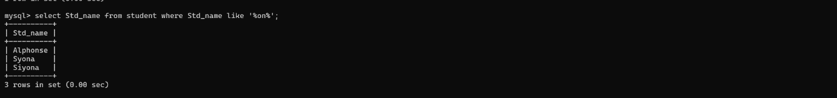

***33)Update a hod and dept name to aruna and advanced computing where course = bda?***

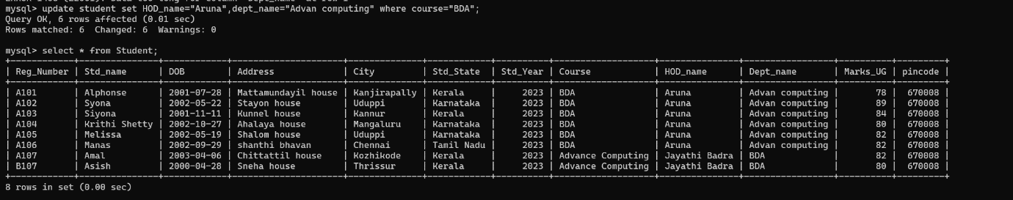

***34)Display age of the student?***

***35)Illustrate where clause with in.***

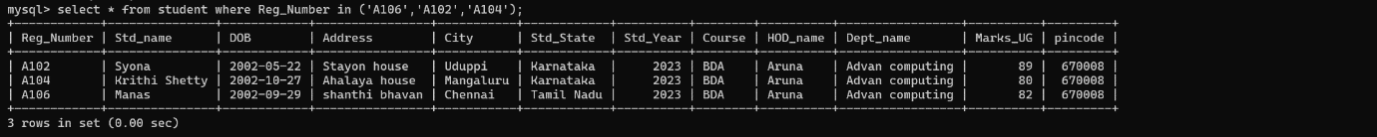

***36)Illustrate where clause not in.***

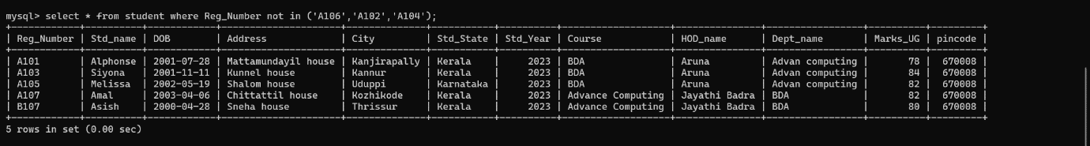

***37)Insert three records each***

***38) Display the records from both the table***

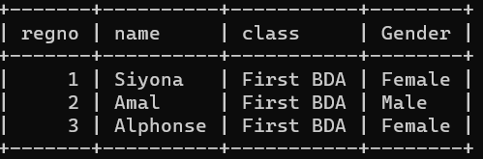

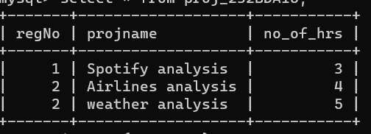

***39)display regno, gender, project name of each student***

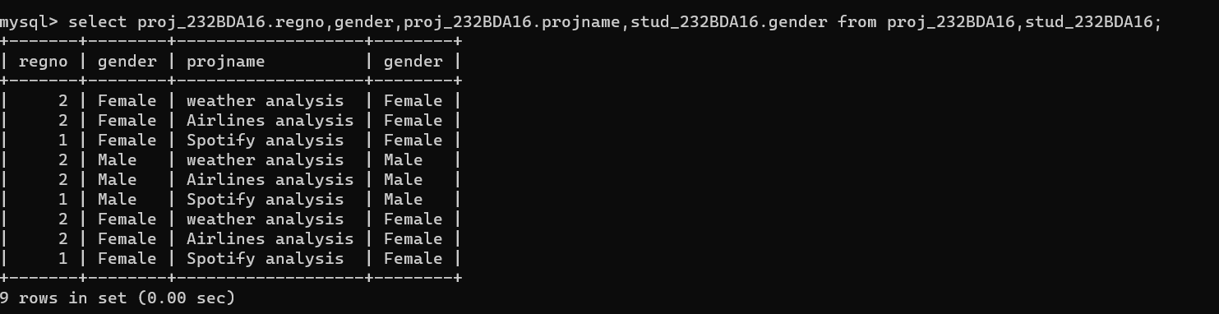

***40) Illustrate left join***

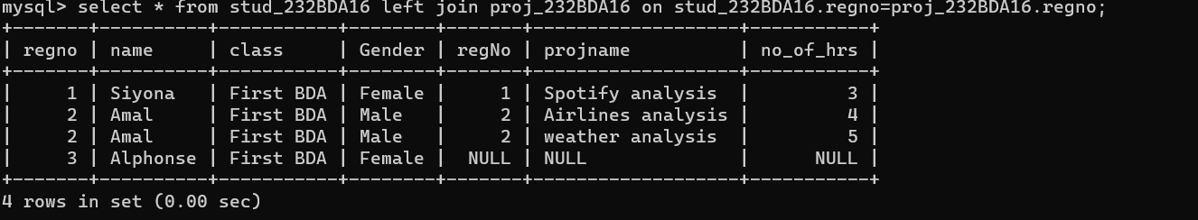

***41) Illustrate right join***

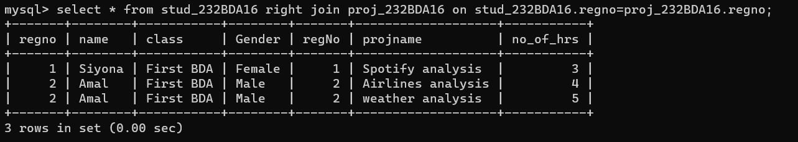

***42) Create a view pro_details to store regno and their project name***

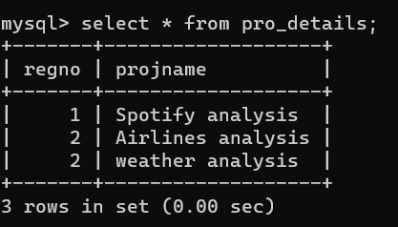

***43) Display the student who has done more than one project***

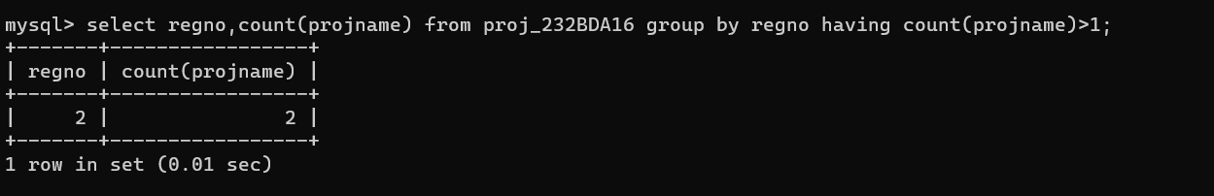

***44) Display student data who has not done any project***

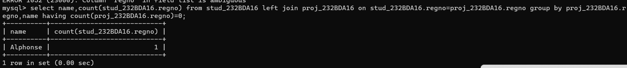

***45)dispay total number of project hour for students***

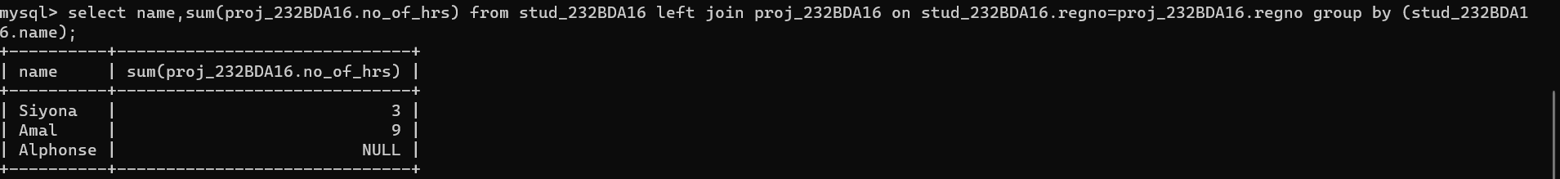

***46).Is it possible to delete parent table data without deleting child table data. ? Justify your answer***

***Ans:***

***NO***